Note. This is a general guidance document, please refer to individual design brief specifications as the primary reference.

Dimensions & Sizes
Examples of Wallpapers, Textiles and Fabric dimensions
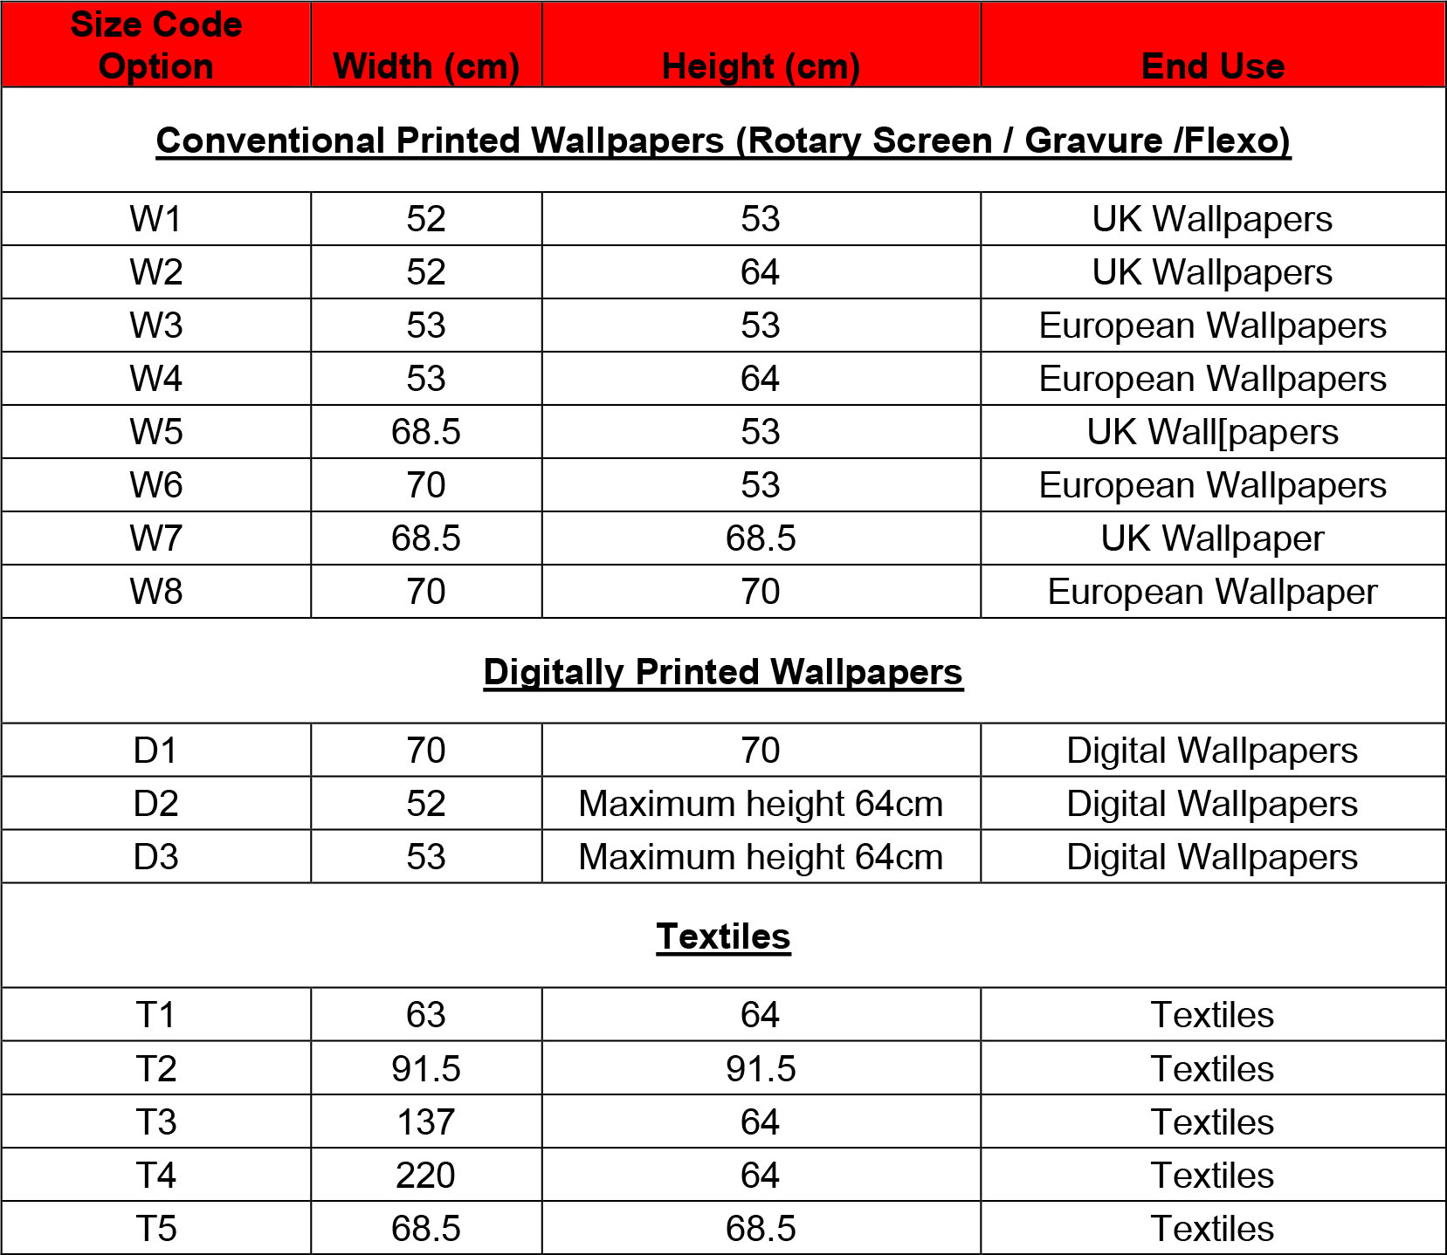

MURALS
Here you must work to the size/s stated in the design brief.
When submitting your digital image, it should be submitted as a whole, e.g., M1 dimensions would be 140cm x 300cm. There is no need to mark or indicate individual panels. Insure that the match it detected on the outside edges of your work.

Size Code Option | Width (cm) | Height (cm) | End Use
Please refer to the illustrations below for clarification
M1 | 2 x 70 | 300 | Mural
M2 | 3 x 70 | 300 | Mural
M3 | 4 x 70 | 300 | Mural
M4 | 5 x 70 | 300 | Mural
M5 | 6 x 70 | 300 | Mural
M6 | 7 x 70 | 300 | Mural

Illustrations of mural options
